Content is logically stated and organized
Content is logically stated and organized. Line of reasoning indicates your group extensively understands and is able to apply relevant consultancy and change management concepts to address the issues. Line of reasoning is supported by convincing evidence. Suggestions/ problem solutions are distinctive and creative, yet pragmatic. All or almost all of the written works are well-organized and well-written (grammar and spelling), clear and fluent. In the oral presentation, your group demonstrates high level of group work in planning, organizing, presenting and managing time. The oral presentation has a clear sense of unity. Your work is able to stimulate new thinking for the class to understand/discuss different aspects of consultancy and change management.

Working in small groups, you need to analyze an assigned case in the capacity of management consultant and deliver an oral presentation on Apr 14. On presentation day, your group will have about 20 minutes (subject to class size) to present your work. You’re required to upload the presentation file on Blackboard before noon on Apr 14. Late submission is subject to 2-point deduction every 30 minutes. Upon completing all group tasks, all group members should receive the same marks, ideally. There are two exceptions. One, within the group, if a significant number of members report individual(s) as free rider(s), the individual(s) will receive a lower score than others in the group. Two, being present is critical. If anyone in the group fails to attend the consulting project oral presentation, he/she will receive a lower score than others in the group. You will receive feedback on both oral presentation and written report on Blackboard in around two weeks.

TO-DO
Slide structure + content division agreed on in meeting (March 31st)
- Introduction + Case Solution and approach (use slide template)
- Analysis (Market Landscape & Product) - Alison
  - Focus on strengths/opportunities to leverage
  - Customer (main focus), industry, competitive analysis
  - Understand what lead to the ingredient into the product (supply chain issue, third party, quality control lack)
- Impact (Problem Breakdown) (TBC) - Alison
  - Financial implications (recall costs, potential lost sales), brand reputation damage, impact on market share
  - Non-financial: Health concerns, loss of trust, inconvenience of returning products, shelf space, consumer impact
- Actions (Short, Medium, LT) - Anthony (ST), Leo (MT), Crysta (LT)
  - ST: recall with efficient communication with consumers and retailers
    - Prevent the situation from blowing out of proportion and leading to worse actions (damage control - Stakeholder engagement/Communication strategy)
    - Need to address both B2B and B2C
  - Medium: Implement new internal procedures to prevent harmful ingredients from re-entering products or entering other brand lines (Organisational change)
  - LT: opportunity to grow and strengthen community by shifting the brand image of old spice to have natural/sustainable ingredients good for the human and earth (Stakeholder engagement/Communication strategy)
  - ^^^ Potentially think about a new product launch based on consumer’s needs and wants discovered through the crisis
    - Key is about being transparent with customers and reconnecting with them again
    - Maybe also consider new pricing strategy + promotion
    - Emphasize needs to be reestablished on the product
  - Timeline + Key performance indicators (KPIs) - Hans
  - Risks & Mitigations
  - Conclusion
_______________________________________

1-page Slide for Joyce on 7/4:
Problem Breakdown:
- Problem 1: Recall cost
  - Supporting service for current Old Spice customers, compensation for retailers, logistics cost
- Problem 2: Reputation
  - Health risk increase with prolonged use of affected deodorant
  - Negligence in manufacturing process -> P&G not able to provide superior products -> reputation⬇️
  - 55% switch brands, 15% never buy recalled product again, 21% no longer purchase P&G produced products
- Problem 3: Shelf space
  - Harming supply chain partnership
  - Retailers might allocate shelf spaces to competitors?

Market landscape and product
- Brand image of P&G
  - Strong brand portfolio: significant recognition + high customer loyalty -> ✅ retain customer
  - Diverse product range: diverse product offerings across different segments -> maintain sales during recalling of products (beauty products hold only 19% of revenue)
- Market & Consumers
  - Expect sales growth from 2021 to 2026
  - Consumers knowledge about ingredients in deodorant⬆️
  - Health conscious consumers⬆️ -> rising demand for natural ingredients: Consumers value more on natural formulation, (also with the price and affordability)
  - Awareness of hygiene, fragrance of various format⬆️
- Competitors
  - Native having 46.8% growth in 202, comparing to the 4% growth of P&G’s -> more natural ingredients are used
  - Intense rivalry: a lot of competitors which sell similar products, has to differentiate P&G from them (e.g. Unilever, Henkel, Colgate-Palmolive, and Revlon)

Original Goal: Prevention of future harm & Brand reputation

Strategy Slogan/Key Direction: To demonstrate that P&G’s call back is not simply “damage controlling” (as it shld be within safety standard), but it's P&G's commitment to consumer safety and proactiveness in doing so. (TBC)
- provide branded products and services of superior quality and value that improve the lives of the world’s consumers, now and for generations to come. (from their website)

Strategy 1: Responsive action to address the immediate concerns of consumers and the impact on retailers.
- Sub-strat 1.1 (Brand + Marketing Team)
  - 1. Team to frequently provide media communication to consumers on updates, being active to address consumer’s questions/concerns
  - 2. Provide alternatives for consumers - with refund to consumers owning the product and providing further support to those impacted by products
- Supporting Data:
  - 1. transparency and proactive communication are crucial for maintaining consumer trust during a crisis (CITE)
    - Rational: consumers will trust Old Spice if they openly address the issue, provides clear information, and take responsibility
    - Rational: information spreads quickly in the digital age, simultaneously allows misinformation from being spreaded
  - 2. Call to actions to reduce product exposure and damage done through product can reduce risk to consumers
    - Rational: focusing on brand reputation through initial financial loss from processing returns and aiding customers often leads to better long-term impacts. (CITE)
    - Rational: collecting first hand data from consumers provides valuable insights to make further decisions, allowing P&G to cater their strategy and messaging in the long term
- Sub-strat 1.2 (Account Executives)
  - 1. maintain active engagement with larger retailers (walmart, sobeys, loblaws, etc.)
  - 2. Look for alternatives to fill up shelf space (i.e. Gillette, Olay)
- Supporting Data:
  - 1. retailers have grown more powerful relative to packaged goods companies as competition grows and product diversification grows (CITE).
    - Rational: as a large CPG company, its important to maintain a positive relationship and proactively act to ensure retailers remain happy during the crisis. Ignoring them will result in damaged relationships and strained LT success.
    - Rational: This situation is an opportunity to build rapport and have retailers more supportive to our company if another occurrence arises.
  - 2. 82% of the surveyed respondents said they prefer buying CPG products in-store at retailers (CITE) - Beauty makes up 19% of their sales & 22% of their net earnings, a significant margin (⅕).
    - Rational: Maintaining that shelf space in the long term is important for the continuing success of Old Spice. Losing that shelf would reduce brand visibility and overall sales.
    - Rational: Retaining that shelf space is crucial to reducing competitors stealing from our brand’s market share.

Strategy 2: Strengthening quality assurance through operational changes, hence regaining and rebuilding customer trust
- Sub-strat 2.1: Implementing advanced monitoring system & revised testing procedures
  - Leveraging technologies like IoT-based monitoring tools within the production lines and blockchain to capture and store real-time data, hence preventing future contamination / QC incidents (also synergising w/ sub-strat 2.2 by providing data for the risk mgnt platform)
  - Enhance the current safety check in QC through both internal testing protocol revamp and introducing third-party verifications from independent labs (and also synergise w/ strat 3 for brand rebuild)
- Sub-strat 2.2: Enhancing supply chain transparency & demonstrating long-term commitment to quality and safety
  - Integrate suppliers and vendors (supply chain) into the product QC platform to increase end-to-end visibility and centralize the risk management process
  - Getting third-party certifications from recognized international quality bodies (e.g. Schmidt’s Naturals) [which is actually already done during sub-strat 2.1]
  - Rebrand and emphasize on the brand’s commitment to safety by effectively communicating and demonstrating the above to both the clients/partners and consumers through: Digital marketing, packaging, etc. & implement such messages into strat 1
- Support data/case
  - Nestle’s case: Blockchain in supply chain & product QC procedures https://www.nestle.com/media/pressreleases/allpressreleases/nestle-open-blockchain-pilot
  - Schmidt’s Naturals third-party certification: https://schmidts.com/ca/en/certifications-and-awards
  - blablabla
Strategy 3:
- Sub-strat 3.1 - Product Diversification
1. Non-aerosol product (e.g. deodorant, shampoo, body wash in stick & gel)
2. Natural deodorant – aluminium-free, only GRAS and essential ingredients

- Supporting Data
1.1 Provide more trustworthy options for customers
o Benzene will only be produced when aerosol products are improperly handled during the manufacturing process.
o Unlike sprays, non-aerosol products such as gels and stickers face no benzene concerns, making them more trustworthy after the recall crisis.
2.1 Introduce natural products to cater the social trend
o Growing concerns that aluminium-containing products may lead to breast cancer or Alzheimer’s. (70-80% of the deodorants in Old Spice contain aluminium.)
o Major competitors such as Native and Dove grew market share in natural deodorants. The top 10 most popular deodorants in the U.S. are all natural deodorants.
o -Gen Z demands for a clean product with less synthetic ingredients.

- Sub-strat 3.2 – Brand Proposition
1. Hold the original core value of “Humour, Irreverent and Confidence”
2. Emphasize on “Inclusivity”

- Supporting Data
1.1 Core values can be easily embedded in digital & social media promotion
o Shift customers’ attention away from the recall by launching different campaigns. Strengthen Old Spice’s image of being a humorous brand, at the same time address its trustworthiness.
o Promotion means AI generated ads, TikTok, YouTube, Instagram in the forms of memes or short clips which can facilitate a viral spread among the young generation.
o Accurately matches with new customer (Gen Z’s media habit)
2.1 Customers tend to buy product when the core value resonates with them
o Inclusivity has become a critical societal and commercial issue in the U.S., influencing politics, corporate policies, and consumer behaviour.
o Creates emotional connection with the audience (especially Gen Z in the USA) who prefer brands that do not take themselves too seriously.
o A 2023 Nielsen study found 72% of men aged 18-34 are more likely to buy from brands that make them laugh.

Impact:
Timeline + KPIs:
- Short + Medium Term
  - Recall Rate: % of products successfully recalled/refunded from estimated total customers owning the product
  - Net Gain/Loss: Total loss for refund + providing alternatives
    - Will be used for ROI(return of investment) in the long term
  - Conversion Rate: % of customers that bought/received an alternative product after refunding
  - Customer Satisfaction Score (CSAT): Average customer satisfaction score on (mandatory?) surveys conducted after successful refund
    - (1 - Very Unsatisfied, 2 - Unsatisfied, … , 5 - Very satisfied)
  - Net Promoter Score (NPS): Average score on (mandatory?) surveys conducted for customers willing to promote the product to others: ‘How likely is it that you would recommend [Old Spice] to a friend or colleague?’
    - (0 - 6: Detractors, 7 - 8: Passives, 9 - 10: Promoters)
  - Media Sentiment Analysis: Using Natural Language Processing (NLP) and machine learning, evaluate the emotions, attitudes, and opinions behind the words into positive/negative used in the following media:
    - Social Media platforms (Instagram, Facebook)
    - P&G/Old Spice Website
- Long Term
  - Market Share: Determine if market share of Old Spice is maintained as before the recall, or increased/decreased. Calculated by dividing total company sales with industry sales
  - Annual Sales Growth: Sales growth of P&G compared to last year
  - Return of Investment (ROI): Compiles profit-related information into a single metric that helps communicate overall performance. Calculated by subtracting total marketing efforts’ cost from their generated revenue, then converting to %.
  - Retention Rate: % of customers that bought/received new natural products introduced in 3.1 from long-time customers in 2021
  - First-time Purchase Customers: Amount of new customers that purchase products in 3.1
Risks + Mitigations:
- Recall rate is too low:
- Intensify public relations program using such tools as revised press releases, press kits, point-of-purchase materials, and trade press materials
- Incorporate recall program into website, online customer service, and/or hotline functions
- Individual letters and contact information to distribution chain (retailers, consumers, distributors)
- Special regional marketing campaigns for ‘underachievers (regions with low recall rate)’
- Customers are dissatisfied with the refund/alternative product in 1.1:
- Conduct comprehensive mandatory surveys to address issues early
- Provide multiple alternatives to choose from
- Lack of response speed/adaptability of overall recall process:
- Assign only one senior executive to manage all of the process
- Development (and regular review) of a recall manual that details clear company’s policy and guidelines
- Appoint a response team, including a “recall champion,” to manage the recall on a daily basis. The response team should be made up of those people the manager has tapped in advance from the various areas in the company.
- Lack of recognition of recall readiness from employees involved in the recall process (customer service and logistics):
- Recognize the severity of the issue first and foremost
- Foster recognition early through training, workshops to ensure the CS recall team knows how to handle all types of customers
- Establish and communicate a clear system and consider conducting mock recalls to test logistic systems
- Government enforcement and legal liability:
- Involve outside counsel with appropriate expertise (securities law, civil litigation, and government investigations and enforcement actions) In-house attorneys should seek advice both on recall strategy and any communications and actions undertaken in connection with a recall
- Scrutinize communications whether internal to the company, or external to regulators and supply chain partners with focus on potential legal action, and have these communications reviewed by in-house and outside counsel
Citations:
- A Strategic Approach to Product Recalls [Risks + Mitigations 1-4]
- CPSC's Recall Checklist [Risks + Mitigations 1]
- Managing Product Recalls [Risks + Mitigations 5]
- How can sentiment analysis be used to improve customer experience?
- CSAT vs NPS
- 7 Marketing KPIs
________________________________________

Content done (April 5th - confirm) - (if we don’t agree) meet sunday night 9pm
Slides content done w/ initial script for review (April 11th)
Presentation Practice (April 13th) - meet in person if possible
Presentation date (April 14th)
Final Report?
- Confirm if need to complete

Present one slide to Joyce for feedback

This case is designed for use in undergraduate- and graduate-level courses on marketing management, in a segment on product management and brand management. It can also be used in a brand management course on managing product recalls. After working through the case and assignment questions, students will be able to
- identify the causes and consequences of product recalls and how they might be avoided;
- examine the role of marketing communications in product recalls, especially direct marketing and public relations; and
- identify the factors in product recall effectiveness and success

QUESTIONS TO ASK

- How much time do we have? 15mins
- Should we measure impact of status quo? (part of plan but not what we present)
- How do you feel about having a supply chain action (ok - need to add value to company)
- Do we need a written report. No. PPT uploaded one day before the presentation.
- How do we present during and post recommendations.

https://hbr.org/1996/09/a-strategic-approach-to-managing-product-recalls 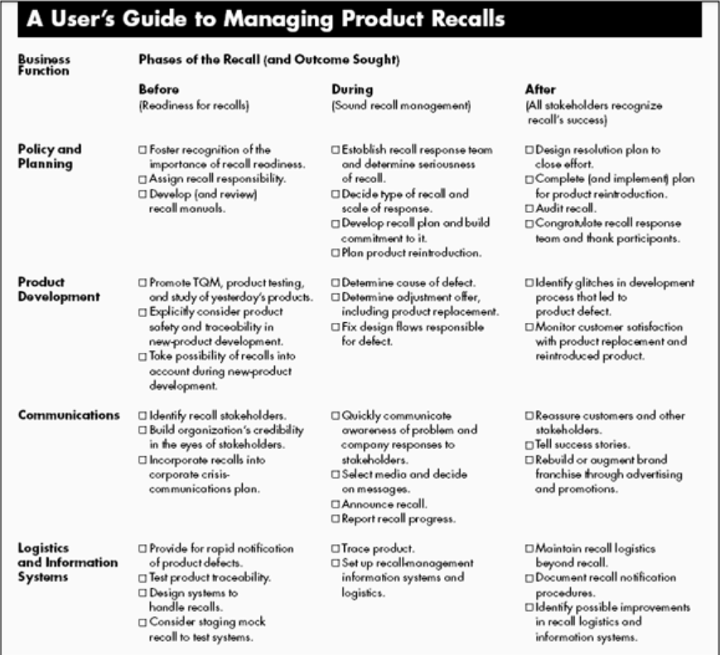

Problem Analysis

Consultant Summary: P&G Recall Case

Background
In November 2021, P&G initiated a recall for more than a dozen Old Spice and Secret aerosol deodorants after benzene—a known carcinogen—was detected. Although the company maintained that the detected benzene levels were not immediately harmful, the recall was a precautionary response to mitigate any potential risk to consumers.

Core Problem Statement
The recall poses a dual challenge for P&G. It threatens to damage the brand’s reputation, thereby undermining consumer trust and potentially reducing sales in a highly competitive North American deodorant market, while also complicating operational and stakeholder relationships across the supply chain and with retail partners.

Breakdown of Key Problems
- Consumer Safety and Health Concerns
  - Issue: Detection of benzene, a carcinogenic substance, in everyday consumer products.
  - Implication: Even though exposure levels are deemed not immediately harmful, the mere presence of benzene triggers consumer anxiety and potential legal scrutiny.
  - Consultant Consideration: Evaluate risk communication strategies and clarify technical details to reassure consumers and regulators.
- Brand Reputation and Consumer Trust
  - Issue: The recall can erode the longstanding trust consumers have in P&G’s quality and safety standards.
  - Implication: A decline in consumer confidence can extend beyond the recalled products to other product lines, especially in a market with only modest growth.
  - Consultant Consideration: Develop a robust crisis communication plan that leverages P&G’s superiority initiative, emphasizing product quality, transparent operations, and proactive customer service.
- Financial Impact and Market Share
  - Issue: With US deodorant sales growing only by 4% in early 2021, P&G was already facing modest growth in a competitive market.
  - Implication: The recall may not only incur direct costs (refunds, logistics, disposal) but also hamper future revenue through lost customer loyalty and potential market share erosion.
  - Consultant Consideration: Conduct a financial impact analysis to understand both short-term recall costs and the long-term effects on market positioning. Explore strategies such as targeted promotional campaigns or strengthening alternative product lines.
- Competitive Vulnerability
  - Issue: The recall provides competitors with an opportunity to capture market share.
  - Implication: Brands like AXE, Dove, and Suave may use the situation to highlight their product safety and reliability, exacerbating P&G’s challenges.
  - Consultant Consideration: Assess competitive positioning and responsiveness. Advise P&G on defensive marketing measures that reinforce the brand’s commitment to quality and on potential repositioning strategies to differentiate their products amid heightened competition.
- Operational and Supply Chain Challenges
  - Issue: The recall demands swift and coordinated action across the entire supply chain—from retailers to consumer communications.
  - Implication: Any misstep in recall logistics could further tarnish P&G’s image and complicate relationships with key stakeholders like retailers and regulatory bodies.
  - Consultant Consideration: Map out the entire recall process to identify operational bottlenecks. Recommend process improvements and crisis management protocols to ensure efficiency and transparency.

